Session 1

Learning objectives:

• understand the relationship between a project, a file, a form, and other interaction objects

• create a program consisting of a form with controls (interaction objects) label and command button and image

• adjust the properties of interaction objects

• create simple code behind your interaction objects

• run your project

• save your project as an executable file

Steps To Creating a Visual Basic Interface

There are three main steps to creating an application

1. Create the interface

2. Set properties

3. Write Code

Exercise 1 - Start Microsoft Visual Basic 5.0

Log on
On the Windows NT desktop:
- Click the Start button
- Move the mouse pointer over Programs
- Move the mouse pointer over Microsoft Visual Basic 5.0
- Click on Visual Basic 5.0
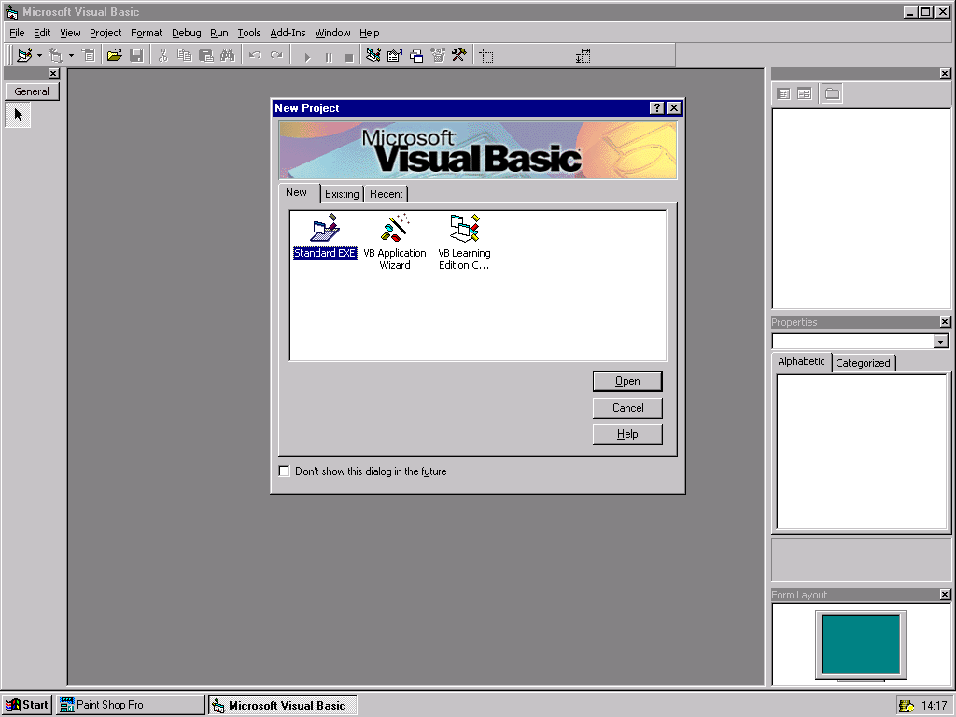
Click Open

Label
Text Box
CommandButton
Picture Box
Image Box
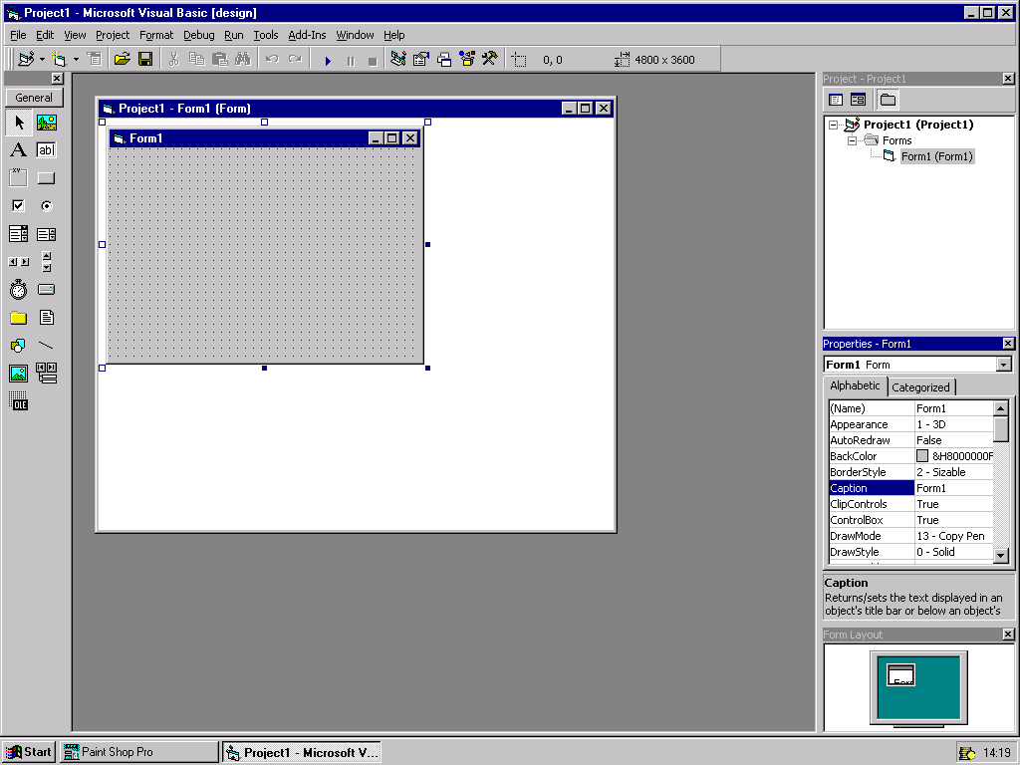
Exercise 2 - Build a pressure tester

Drag a label and a command button across onto your form.
Edit the captions of the form, label and button as shown below.
Form caption

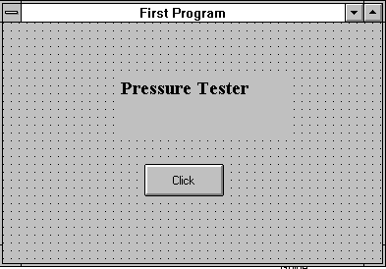
Label
Command button

Now try putting a border around your label and changing other properties. Now double click on the command button to add the code will make a click effective. A window will open containing two lines of code:

Private Sub Command1_Click()

End Sub

The cursor is waiting in the space between these lines.
Type in the following.

Label1.Caption = “Ouch”
MsgBox “Not that hard!”

Save the project before you run it.
First use File, Save Form As to save the form. When the dialogue box opens check that you are pointing to the right disk and directory, and type in a suitable title, such as ‘pressure’. don’t bother to type the ‘frm’ extension as it is added automatically.
Next use File, Save Project As to save the whole program.
You can call this ‘pressure’ as well. The system will add the ‘vbp’ extension which will distinguish the project from the form file..

Now run your program by using Run, Start and stop it using Run, End.

Add another command button with the caption “Quit”. Double click on the quit button and type the line.

End

The quit button can now be used to end the program.
Try running your new program.

Now make an executable (exe) version of your program. The program can then be run direct from Windows, rather than only through the Visual Basic system.
To do this use File, Make <pressure>.EXE file. When the dialogue box opens you should find that most of the details have been filled in correctly by the system.

Exercise 3 - The Temperature Converter
First start a new project. You will be prompted to save your old project.

This program converts temperatures from Celsius to Fahrenheit and from Fahrenheit to Celsius.
Drag 2 text boxes, 2 labels and 3 command buttons across onto a form.
Edit the captions of the form, labels and buttons as shown below.

You will need to change the name properties of the buttons to cmdConvToF and cmdConvToC. Name the top text box txtCelsius and the other one txtFahrenheit. You can change some of the other properties to your liking, e.g. borders around the labels, coloured captions.

Attach the following code to the cmdConvToF button:
txtFahrenheit = txtCelsius * 9 / 5 +32

Attach the following code to the cmdConvToC button:
txtCelsius = (txtFahrenheit - 32) * 5 / 9

Attach the following code to the cmdQuit button:
End

Exercise 4 - The Launch Program.
This program simulates a simple rocket launch. The 'launch' is produced by changing the Top property (which determines the vertical position) of a control. Other effects are produced by changing properties during the execution of the program. Notice the way that Enabled can be set to False, so that a control will no longer respond to events, and Visible set to False to make a control disappear.

In this program we want the user to be able to set the flight speed, launch the rocket, start again from the beginning, and exit the program.

The layout of the interface is like this:

Text Box
Image Box
Label
Command Buttons

The launch cannot take place until the speed has been set, so the Launch button must be turned off at first.
The speed is set by typing it into a Text Box.
The instructions for the user are written into a label. The same label is also used for a title.
An Image is used to represent the rocket.
Get a picture for your rocket
Either
Start 'Paint' (Start, Programs, Accessories, Paint) and draw yourself a small rocket. Select the rocket image and save it as a bitmap (BMP) file, using Edit, Copy To.

or
Find your own graphic perhaps by saving an image from the Internet and storing them in your area (H: drive). Images you save from the Internet have to be converted to .BMP format. You can do this by going into Paintshop Pro (Start, Programs). Visual Basic likes bitmaps (.BMP) and icon (.ICO) files (other formats can give trouble, so be warned!)

or
Use the picture of a rocket in G:\devstudio\vb\graphics\icons\industry\rocket

Design the interface
Lay out the controls on the form as shown above:

Name the controls as follows:
Label for title - lblPrompt
Speed Text Box - txtSpeed
Start button - cmdStart
Launch button - cmdLaunch
Quit button - cmdQuit
Rocket image box - imgRocket. (NOT a Picture box)

Set the properties
Set txtSpeed Visible property to false.
txtSpeed will be visible when the program is run , and will only appear when the property is reset to True by the start button.

Set cmdLaunch.Enabled property to false.
When the property starts, its Caption will be displayed in Grey, rather than black, and the button will not respond to a click. It will be enabled again by the Change event on txtSpeed.

To get the picture of a rocket into imgRocket:
Set the Stretch property of the image box to True
(this makes the graphic fill the image box)
Select the Picture property of the control
Click the selection option to open the Load Picture dialogue box.
Work your way through the drives and directory lists to find your .BMP or .ICOfile.
Click OK to load the graphic into your control.
Writing the Code
To attach code to an object's event, double-click on the object to open its code window. Clicking on the appropriate objects write the following code.

Double click on the object cmdStart select Click as the action.
Type the following code.

Private Sub cmdStart_Click()
imgRocket.Top = 3000
lblPrompt.Caption = "Enter speed then press Launch"
txtSpeed.Visible = True
txtSpeed.Text = "0"
cmdLaunch.Enabled = True
txtSpeed.SetFocus
End Sub

Click back into form and double click on cmdLaunch and select Click as the action. Type the following code.

Private Sub cmdLaunch_Click()
Do
imgRocket.Top = imgRocket.Top - txtSpeed.Text
DoEvents
Loop Until imgRocket.Top < -5000
End Sub

Click back into form and double click on txtSpeed and select Change as the action. Type the following code.

Private Sub txtSpeed_Change ()
cmdLaunch.Enabled = True
End Sub

Click back into form and double click on cmdQuit and select Click as the action. Type the following code.

Private Sub cmdQuit_Click ()
End
End Sub

Now run your program and then save the project.

Further exercises

- Using the techniques illustrated in the Launch program, design and build a program that will move a small train across the screen. For a more impressive display create a background picture of a landscape and use this as the Picture property of the form.

- Now add moving flames to the bottom of your rocket.

- Make an orange ball bounce around the screen until you press the quit button.

- Produce a system that acts as an annotated diagram. Set up a form with a large diagram as its Picture. Place small command buttons beside key components of the diagram with captions to match the components. Attach code to each of these buttons so that when clicked they display information about the component in a label.

Your “Home directory” is H:<your user ID>
the <text> between the angle brackets is replaced by the name of your file

